AI-Augmented Backend Development Project : AI FAQ ASSISTANT

TITLE : AI FAQ Assistant

Project Description
AI FAQ ASSISTANT is an AI-Augmented backend Web Application developed using the (MongoDB, Express.js, Node.js) integrated with Artificial Intelligence capabilities such as Large Language Models (LLMs), Semantic Search, Vector Search, and Intelligent Recommendations. The system enables users to interact with data through natural language, receive AI-generated insights, perform semantic searches, upload and analyze documents, and automate decision-making processes. By combining traditional backend development with modern AI technologies, the platform delivers an intelligent, scalable, and user-friendly experience that improves productivity, accessibility, and operational efficiency.

Scenario
Identify the Problem
Organizations such as colleges, offices, service centers, and customer-support departments receive many repeated questions from users. Traditional FAQ pages usually depend on exact keywords and require users to manually browse categories and read multiple questions before finding an answer. As the number of FAQs grows, maintaining and searching the information becomes difficult. Manual support also consumes staff time because common questions have to be answered repeatedly
- Explain the Need for AI
A traditional keyword-based FAQ system may fail when a user asks the same question using different words. Artificial Intelligence can understand the semantic meaning of a question rather than depending only on exact keyword matches. Embedding models and vector search can identify FAQ entries that are semantically related to the user's query. An LLM can then use the retrieved information to generate a clear natural-language response. RAG helps the system ground the answer in the stored FAQ knowledge.

- Describe the Proposed Solution
The proposed system provides an AI-powered FAQ assistant. Administrators can create, update, delete, and organize FAQ entries. When a user submits a question, the backend generates an embedding for the query, performs semantic/vector search against stored FAQ embeddings, retrieves the most relevant FAQ information, and sends the retrieved context to an LLM. The generated response is returned to the user and the interaction is stored in chat history.

Structure :
Paragraph 1 – Problem:
Many organizations receive the same questions repeatedly from users. Traditional FAQ systems require users to search manually or use exact keywords, making it difficult to find the correct answer when the question is asked in different words. This increases the workload for support staff and causes delays in getting information.
Paragraph 2 – AI Solution:
The proposed AI-Powered FAQ Management and Question Answering System uses Artificial Intelligence to understand users' questions in natural language. The system uses AI Chatbot, Question Answering, Semantic Search, Vector Search, and RAG (Retrieval Augmented Generation) to find relevant FAQ information and generate a clear answer. FAQ data is stored in MongoDB, converted into embeddings, and searched using MongoDB Atlas Vector Search.
Paragraph 3 – Impact:
The application benefits students, customers, employees, and other users who need quick access to frequently asked information. Administrators can easily manage FAQ content, while users can ask questions naturally instead of manually searching through FAQ pages. The system reduces repetitive work, improves response speed, and provides an easier and more intelligent way to access information.

System Requirements :
To ensure smooth development, deployment, and usage of the AI FAQ Assistant AI-Augmented Backend Application, certain system prerequisites must be met.

1. Software Requirements

Operating System
- Windows 10/11
- macOS
- Linux

Node.js (v18 or above)
Provides a runtime environment for frontend and backend development.

npm (v9 or above)
Package manager used for dependency installation.

Express.js
Backend framework used for API development.

MongoDB Community Server / MongoDB Atlas
NoSQL database used to store:
- User Information
- Chat History
- Documents
- Embeddings
- AI Interactions
- Application Data

MongoDB Atlas Search
Provides full-text search functionality.

MongoDB Atlas Vector Search
Enables semantic search using vector embeddings.

AI Service Provider
- OpenAI API
- Gemini API
- Claude API
- Azure OpenAI (Optional) …etc

LangChain / AI SDK
Used for orchestration of AI workflows.

Browser
- Google Chrome
- Mozilla Firefox

Postman
API Testing

Visual Studio Code
Development Environment

Git & GitHub
Version Control

2. Hardware Requirements

Processor
Intel Core i5 (8th Gen+) / AMD Ryzen 5+

RAM
Minimum 8 GB
Recommended 16 GB

Storage
Minimum 5 GB Free Space

Internet Connection
Required for AI API communication

Display
1366 × 768 or above

Project Architecture

Technical Architecture :
NOTE : Add a relevant Architecture diagram.

Backend Layer
- Node.js
- Express.js
- JWT Authentication
- REST APIs

Database Layer
- MongoDB
- Atlas Search
- Atlas Vector Search

AI Layer
- LLM APIs
- Embedding Models
- RAG Pipeline
- Prompt Engineering

Storage Layer
- MongoDB Collections
- File Upload Storage

Security Layer
- JWT Authentication
- Protected Routes
- Input Validation
- Role-Based Access Control

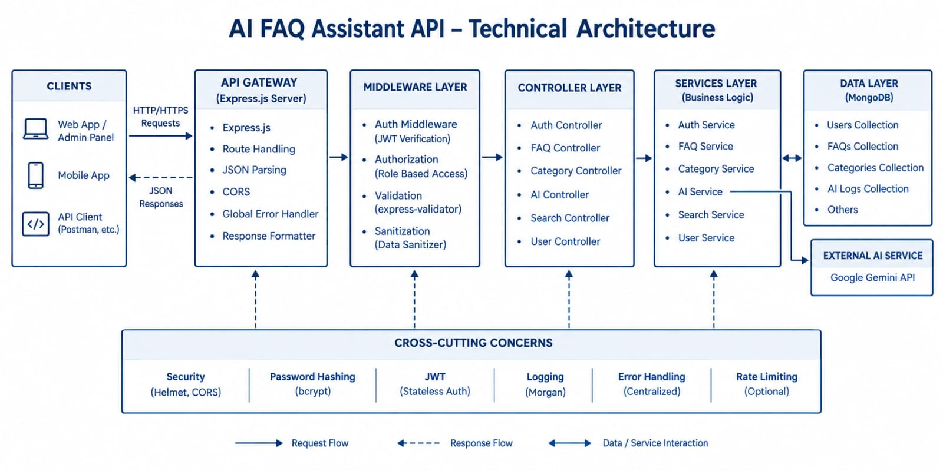

ER Diagram
NOTE : Add a relevant ER diagram.

Collections

Users
- _id
- name
- email
- password
- role

Documents
- _id
- title
- content
- uploadedBy
- createdAt

Embeddings
- _id
- documentId
- vectorData

Chats
- _id
- userId
- prompt
- response
- timestamp

ActivityLogs
- _id
- userId
- activity
- createdAt

ER Diagram Explanation
Users can upload documents and interact with AI features. Uploaded documents are processed into vector embeddings and stored in MongoDB. Chat interactions and AI responses are logged for future reference and analytics. Activity logs maintain user actions across the system.
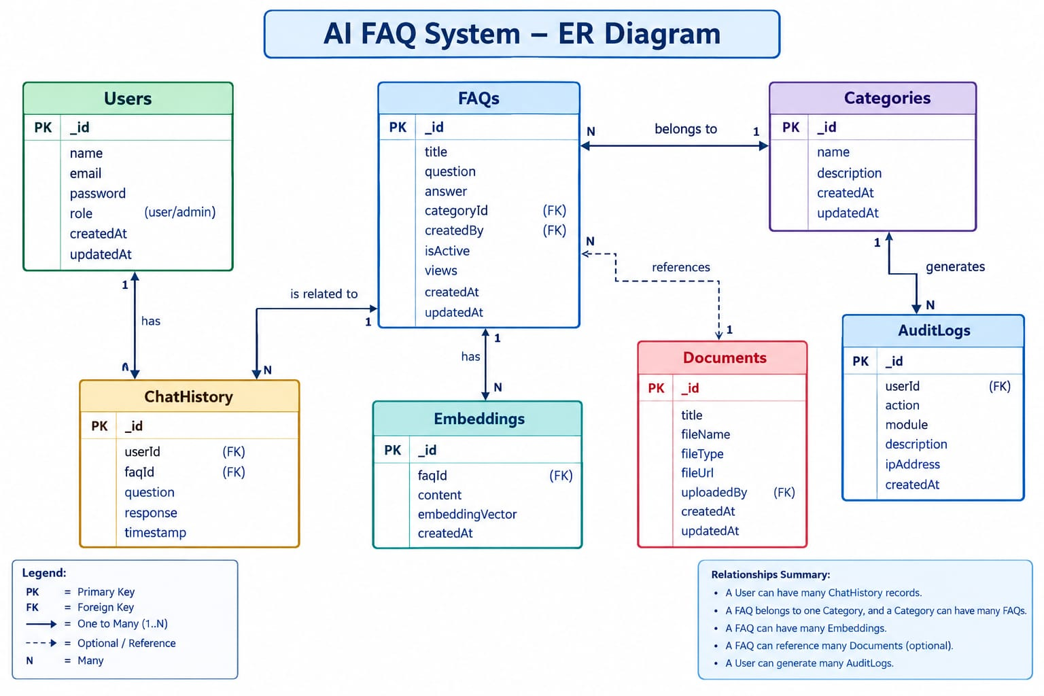

Features

Core Backend Features
- User Registration
- User Login
- JWT Authentication
- Protected Routes
- Middleware
- CRUD API
- File Upload
- Role-Based Access Control

AI Features
- AI Chat Assistant
- Semantic Search
- Vector Search
- Document Question Answering
- Text Summarization
- Content Generator
- RAG (Retrieval Augmented Generation)
- Intelligent Insights
- Natural Language Queries

Roles and Responsibilities

Admin
- Manage Users
- Manage Documents
- Monitor AI Usage
- View Analytics
- Configure System

User
- Register/Login
- Upload Documents
- Ask Questions
- Search Content
- View AI Recommendations
- Manage Personal Data

User Flow
- User Registration
- User Login
- JWT Authentication
- Dashboard Access
- Upload Documents
- Generate Embeddings
- Store Vectors in MongoDB
- User Query Submission
- Semantic Search Execution
- AI Response Generation
- Display Results
- Store Chat History

MVC Pattern
The backend follows the MVC (Model-View-Controller) architecture. This architecture separates database models, application logic, and API routes, making the AI FAQ system easier to maintain and scale.

Model Layer
Responsible for:
- User Schema
- Chat Schema
- Document Schema
- Embedding Schema
- Activity Schema
Implemented using Mongoose.
The Model Layer defines the structure of data stored in MongoDB and manages communication between the application and the database.

Controller Layer
Responsible for:
- Authentication Logic
- AI API Integration
- Document Processing
- Embedding Generation
- Search Operations
- CRUD Operations

View Layer (Routes)
Defines REST API endpoints:

Authentication Routes
- Register
- Login
- Logout

AI Routes
- Chat
- Summarization
- Semantic Search

Document Routes
- Upload
- View
- Delete

User Routes
- Profile
- Dashboard

Advantages of MVC
- Separation of Concerns
- Better Maintainability
- Easy Scalability
- Reusable Components
- Team Collaboration
- Easier Testing

Project Setup and Configuration

Project Structure

Creating Project Folder
- Create a new folder with your AI FAQ Assistant.
- Inside that folder, create a new subfolder named src.
- Now open that folder in VS Code.
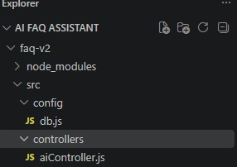

Server Folder
The server folder contains the complete backend application for the AI FAQ Assistant. It includes the Express.js server, database configuration, models, controllers, routes, middleware, and AI services.

Server Setup
mkdir server

cd server

npm init -y
Create:
server.js

models/
controllers/
routes/
middlewares/
config/
services/
utils/


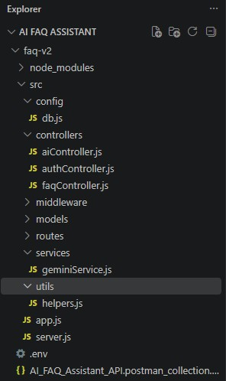

Install Backend Packages
npm install express mongoose cors dotenv bcryptjs jsonwebtoken

npm install openai

npm install multer

npm install nodemon --save-dev


Backend Development

Core System Script Implementations

1. Gateway Server Node (src/server.js)
This main entrance mechanism aggregates environment variables, triggers database listeners, and binds network listeners to active environment ports:
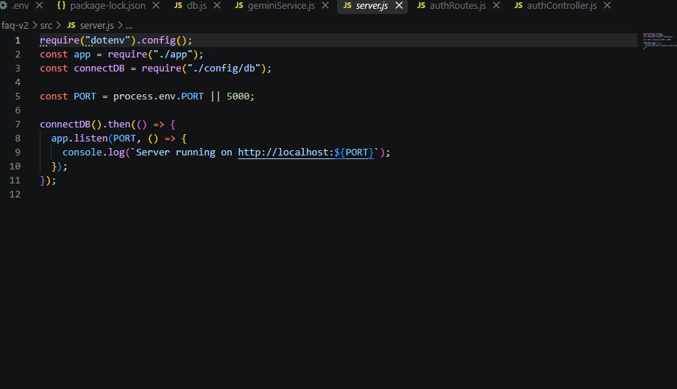
2. Gateway Express Setup (src/app.js)
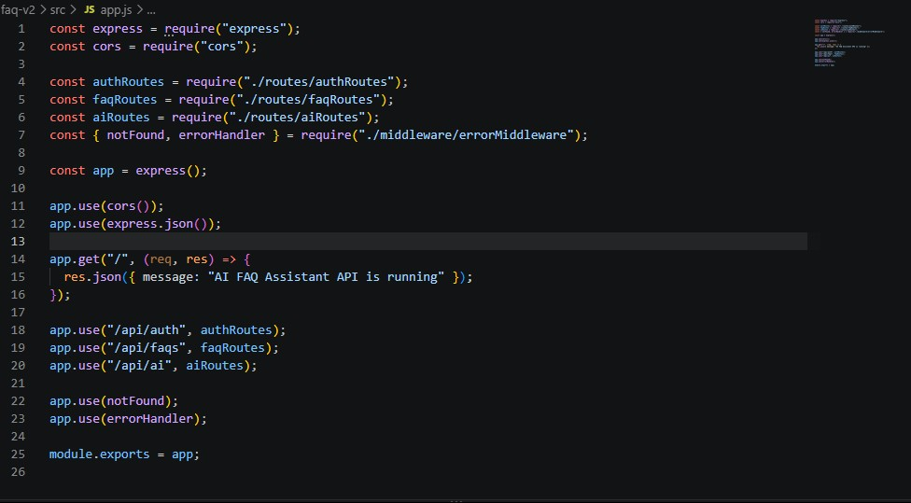

3. Security Access Middleware (src/middleware/authMiddleware.js)
Intercepts incoming target queries, extracts transmission header authorization records, and validates token identity context claims:
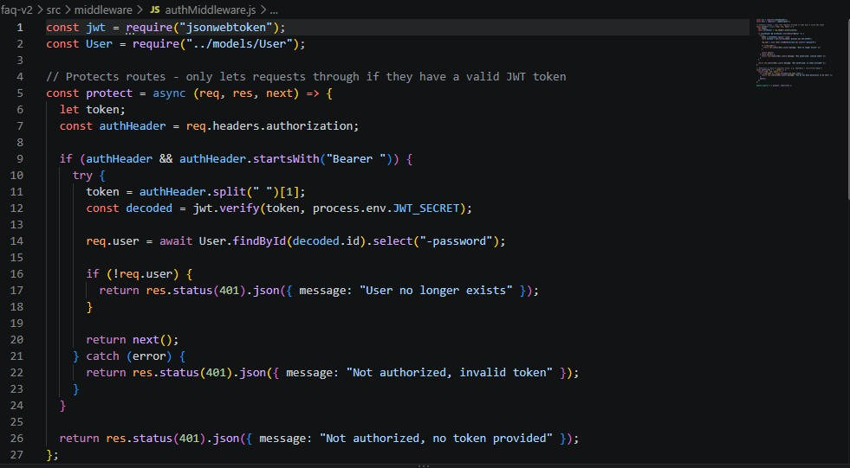

4. Centralized Error Handler Middleware (src/middleware/errorMiddleware.js)
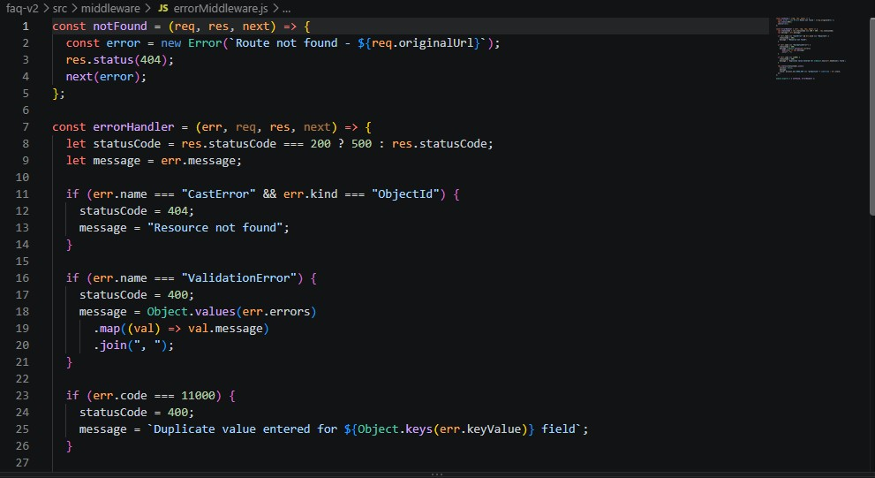

Database Development

Mongoose Schema Definitions

1. Identity Resource Document Schema (src/models/User.js)
Enforces profile field criteria validations and hooks password hashing steps prior to user document persistence:
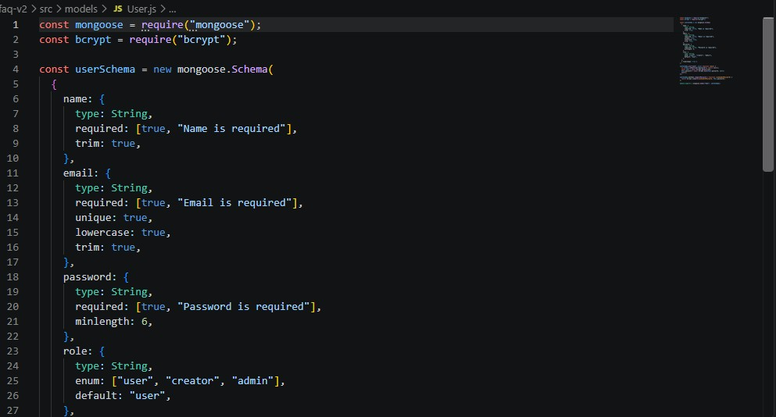

2. FAQ Resource Document Schema (src/models/FAQ.js)
Models core properties and maps a distinct relational reference link back to the source creator document:
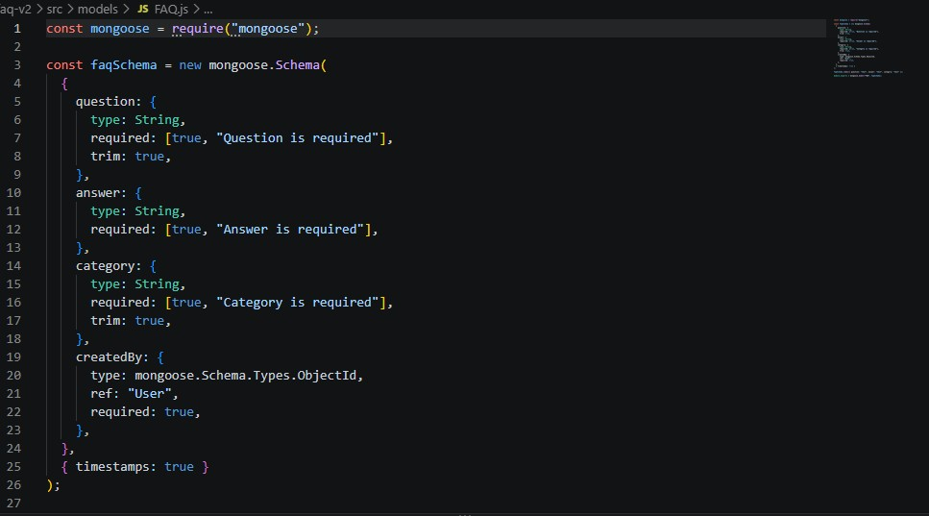

API Router Interface Endpoints

1. Public Authentication Operations (src/routes/authRoutes.js)
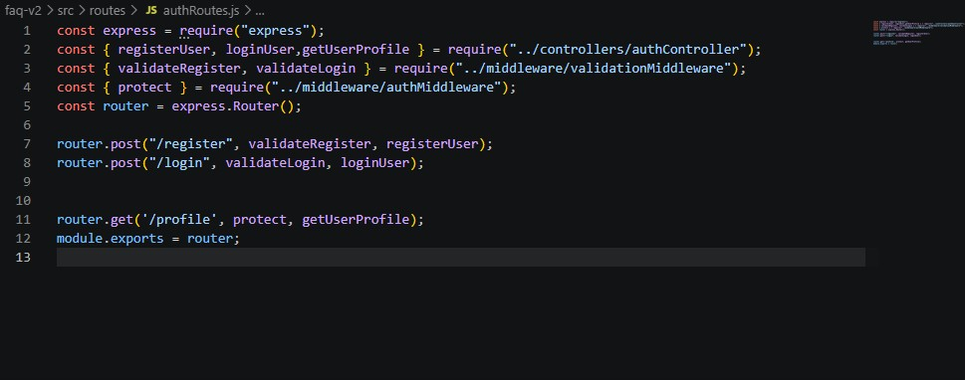

2. Protected FAQ Operations (src/routes/faqRoutes.js)
JavaScript
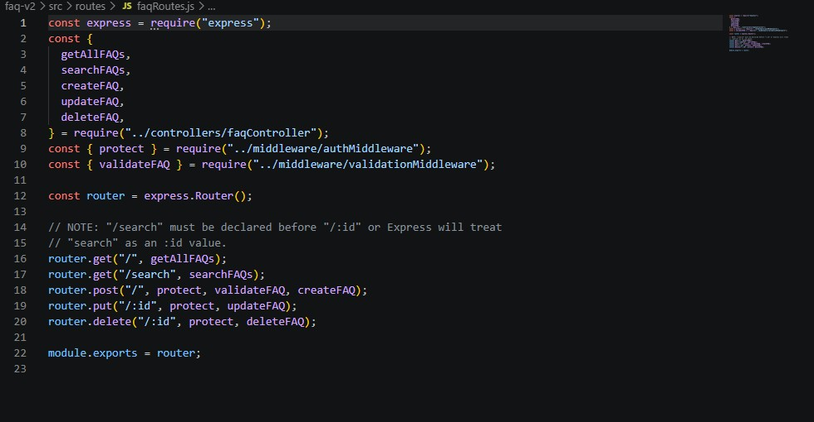

3. AI Automation Operations (src/routes/aiRoutes.js)
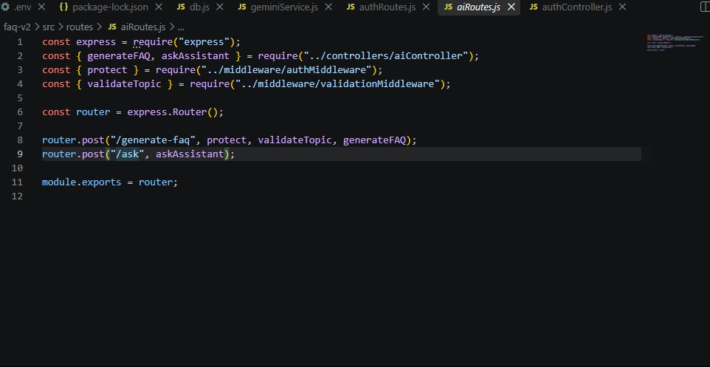

Project Execution

Step 1: Backend
cd server

npm install


Step 2: Configure Environment Variables
Create .env
PORT=5000

MONGO_URI=mongodb://localhost:27017/ai_augmented_db

JWT_SECRET=your_secret_key

OPENAI_API_KEY=your_api_key


Step 3: Run Backend
nodemon server.js
Backend URL:
http://localhost:5000


Output Screenshots with Explanation

Running the API Application
- Install Postman or ThunderClient (VS Code extension).
- Start the backend development server environment parameters:
Bash

npm run dev

API Testing Specification Demo
To verify operational structural integrity via execution endpoints, map endpoints using the configurations below:

1. Identity Onboarding Path Registration
- Route: POST /api/auth/register
- Access: Public
- Payload Request Body JSON:
JSON

{
"name": "thameem",
"email": "thameem2@gmail.com",
"password": "123456"
}
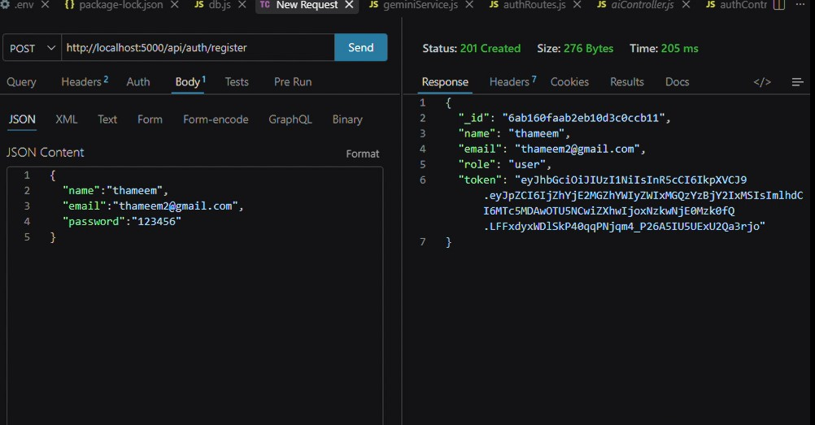

2. Profile Login Verification Quey
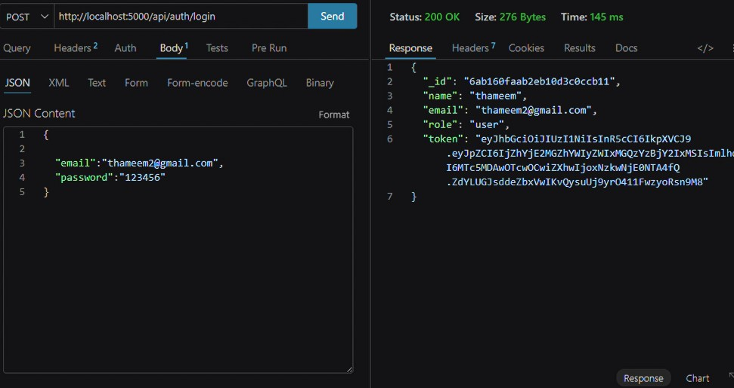

- Route: POST /api/auth/login
- Access: Public
- Payload Request Body JSON:
JSON

{
"email": "thameem2@gmail.com",
"password": "123456"
}

3. Profile Creation (FAQ)
- Route: GET /api/auth/profile
- Access: Private (Bearer <JWT Token>)
- Payload Request Body JSON:
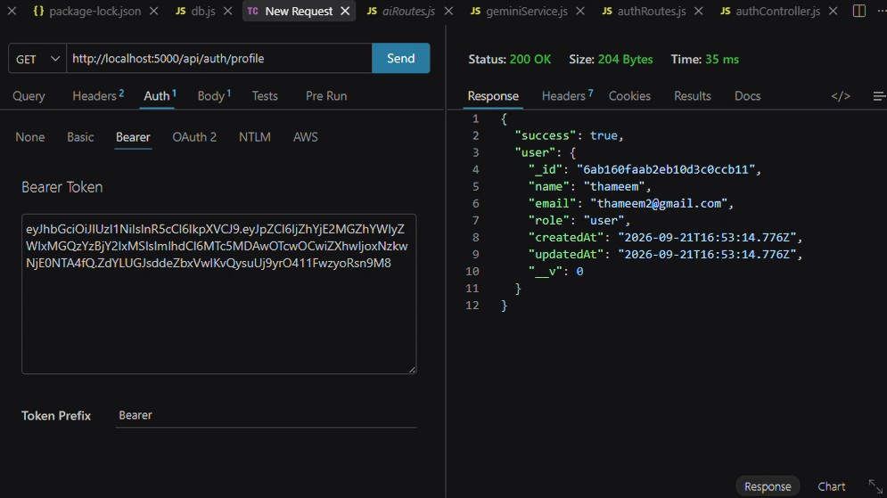

4. AI Intelligent Content Automation
- Route: POST /api/ai/ask
- Access: Private (Bearer <JWT Token>)
- Payload Request Body JSON:
JSON

{
"{
"question":"what is Node.js"

} "

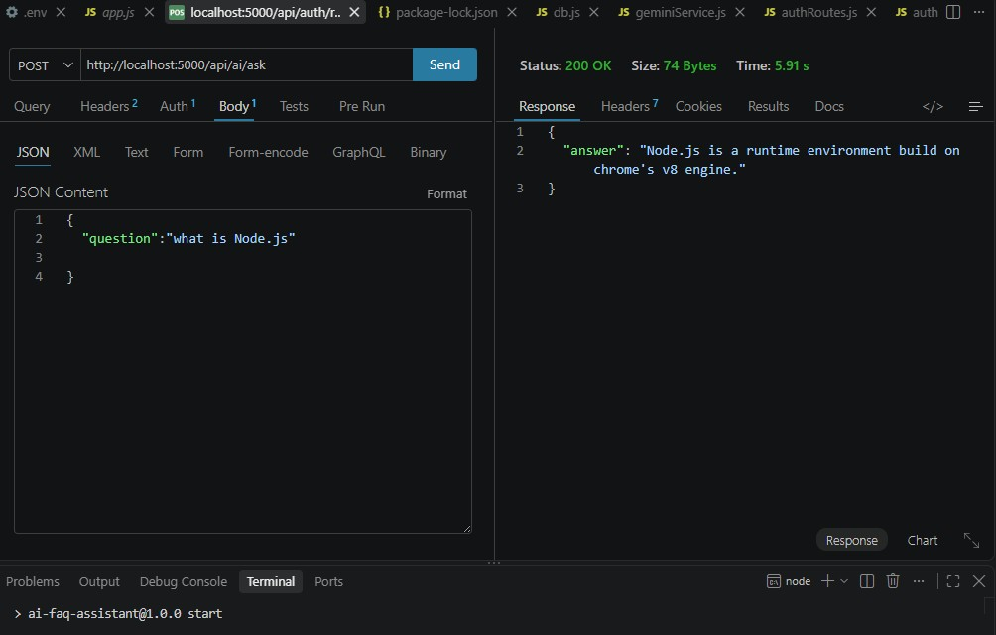

Demo Video Link
https://drive.google.com/file/d/1VOs2iT5TT_WzOQUDxKc_-6Pf7wHI3N8d/view?usp=sharing

Source Code Drive Link
https://drive.google.com/drive/folders/1la1SDfPefXAqpGbmXMiargqlpAgzWqwr?usp=sharing
API Testing
https://drive.google.com/file/d/1zOI0Pm3NkXhBRYxNPWF42lYSTvAWtlqc/view?usp=sharing

Mandatory Functionalities
- MVC Architecture
- JWT Authentication
- Semantic Search
- MongoDB Atlas Search
- MongoDB Atlas Vector Search
- Prompt Engineering
- AI API Integration
- Role-Based Access Control

